|  |  |  |
| --- | --- | --- |
| Unimoni Competitor Analysis | | |
|  |  |  |
| **Muthoot Finance, Manappuram Finance, Bajaj Finance** | | |

# NBFC Industry Overview

NBFCs (Non-banking financial companies) are financial institutions registered under the Companies Act, 1956 of India, that offer various banking services but do not have a banking license. Their operations are regulated by the RBI (Reserve Bank of India) and are required to comply with some laws, which helps differentiate them from banks. NBFCs typically borrow money from banks or sell commercial papers to mutual funds to raise money. They on-lend these money to small and medium enterprises, retail customers and so on. NBFCs can offer banking services such as loans and credit facilities, currency exchange, retirement planning, money markets, [underwriting](https://www.investopedia.com/terms/u/underwriting.asp), and merger activities. Various types of NBFCs exist in India including Asset Finance Companies (AFCs), Investment Companies (ICs), Loan Companies (LCs), Infrastructure Finance Companies (IFCs), and Gold Loan NBFCs.

Some of the top 15 NBFCs in India, in terms of Total Revenue, include Power Finance Corporation Limited, Shriram Transport Finance Company Limited, Bajaj Finance Limited, Muthoot Finance Limited, Mahindra & Mahindra Financial Services Limited, Aditya Birla Finance Limited, and Manappuram Finance Limited. We will be analyzing the effect of the IF&LS Crisis as well as product analysis of Muthoot Finance Limited, Manappuram Finance Limited, and Bajaj Finance Limited.

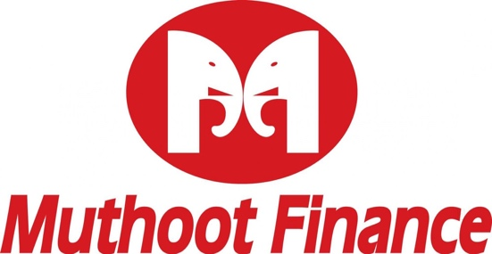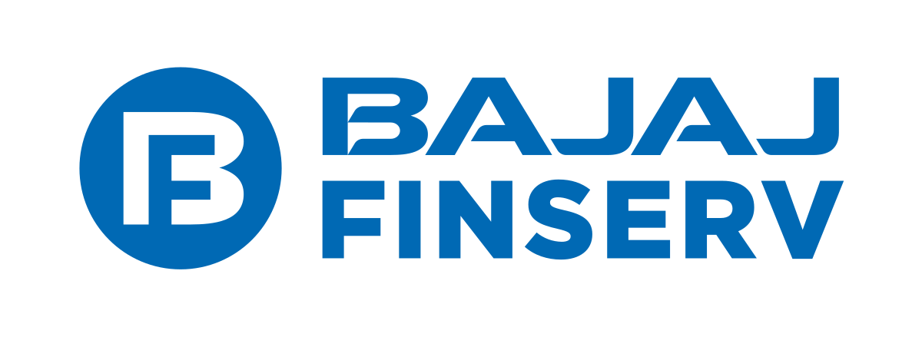

# il&fs Crisis summary

**What is it?**

NBFCs, particularly the smaller ones, are facing a liquidity crunch. In other words, they don’t have money to lend or are facing enormous difficulties in raising funds. When NBFCs don’t have money to lend, that reduces the credit flow to the economy, hits economic growth, and causes many borrowers to default on loans. As a result there was a drastic reduction in lending from October 2018 to December 2018 due to liquidity squeeze, which affected consumption demand in the economy.

**What caused it?**

Firstly, asset-liability mismatch, a flawed business model of the NBFCs that relies on raising short-term funds which are then lent out as long-term loans, is attributable to the crisis. This cycle of renewing short-term loans to repay long-term debt was broken because of default payments to lenders by IF&LS, a core investment company in infrastructure and finance services. Consequently, rating agency ICRA downgraded IF&LS’s borrowing programmes, which caused panic amongst equity investors as well as other NBFCs.

**Consequences of it?**

Macroeconomic growth has slowed down as several NBFCs have faced rating downgrades and tighter access to liquidity. Trillions of rupees are locked in real estate, construction and infrastructure projects. Large NBFCs with strong parents and track records are better positioned than small NBFCs, which could lose market share. Housing finance companies (HFCs) will face sharper slowdowns and this was evident when DHFL, a large mortgage lender, lost almost 10% in May 2018 due to a recent downgrading of its credit ratings of its FDs. However, the main consequence to consider in the context of this report is that some NBFCs, mainly large ones, have faced positive growth since the crisis due to their business model, which will be analyzed further in the report. Conclusion: it is the real estate-focused NBFCs that are in trouble.

# Muthoot finance analysis

**USP:** Largest Gold Financing Company in India in terms of loan portfolio.

**Gold Loan (LAG) Performance:** 14 different type of schemes exist for customer satisfaction and minimum loan amount of Rs.1500 with no maximum limit. Saw a 6% increase in gold loan assets as well as average gold loan per branch and a 4% increase in gold holding from 2017-2018. The future for Muthoot gold loans looks promising due to copious reasons including large volumes of gold being held by rural communities, lower default rates, and the market still underpenetrated. Moreover, **digital lending** has been incorporated in the forms of the iMuthoot app, which has 5 lakh downloads, and Aadhar Card Enabled e-KYC for withdrawals and payments.

**Secured Business Loan (SBL) Performance:** This product is provided by Muthoot Fincorp Limited and Muthoot Capital Services Limited. SBL performance has only been shown through Term Loans advancement to other NBFCs with an amount of ₹ 39,20,45,000 as at March 2018.

**Diversification:** Muthoot Finance bought high stakes in various companies in years 2015 and 2016 and has been increasing its stakes since then. It first diversified its operations in Sri Lanka when it bought 51% of Asia Asset Finance PLC (AAF) in 2015. In 2016 it expanded its product portfolio rapidly when it bought majority stakes in Muthoot Homefin India Limited (MHIL), Belstar Investment And Finance Private Limited (BIFPL – a microfinance NBFC), and Muthoot Insurance Brokers Private Limited (MIBPL).

**Impact of Sept 2018 Crisis:** MuthootFinance Limited remained largely unaffected by the crisis due to their business model. They differ from other NBFCs due to their positive security and asset-liability management (ALM), mainly because they cater to small retail customers, and also due to their ability to raise capital at short notice. Moreover, these type of NBFCs, unlike those that operate in riskier sectors, such as real estate, are viewed with confidence by investors in the stock market.

**Supported Financial Ratios:** The financial ratios calculated corroborate the performance of Muthoot Finance Limited after the crisis. In terms of profitability ratios, the Net Profit Margin % grew from 20.53% in FY17 to 27.6% IN FY18 due to an increase in total revenue, which implies higher sales, and an increase in net income, which implies lower operating and finance costs. Also, ROE increased from 0.194 (19.4%) in FY17 to 0.241 (24.1%) in FY18, returning more profit of each rupee invested by stockholders, and EPS grew 46% over FY17 to FY18 due to increased profitability. In terms of liquidity and efficiency ratios, Total Debt to Equity fell from 3.71 in FY17 to 3.04 in FY18, which represents that more investor financing was used instead of creditor financing, implying less risky business. The Quick Ratio calculated in the sheet differed from figures given in online sites, such as NDTV. My figures showed a positive change in the Quick Ratio, whereas on online sites the Quick Ratio declined from 1.20 in FY15 to 0.94 in 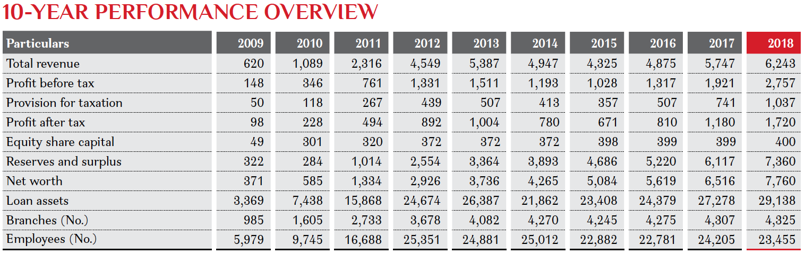FY18, indicating a solvency issue due to increasing debt or depleting cash balance.

in ₹ crore

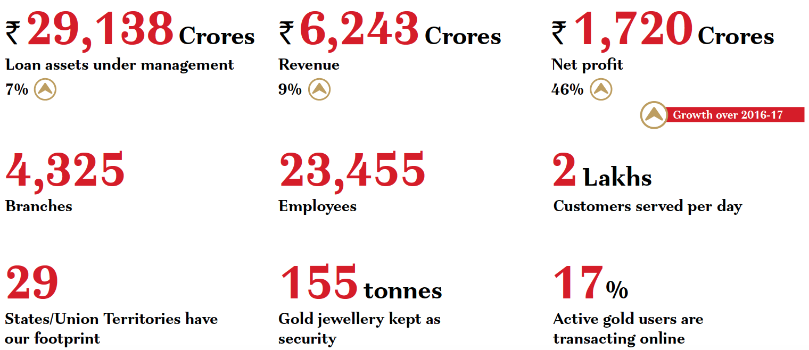

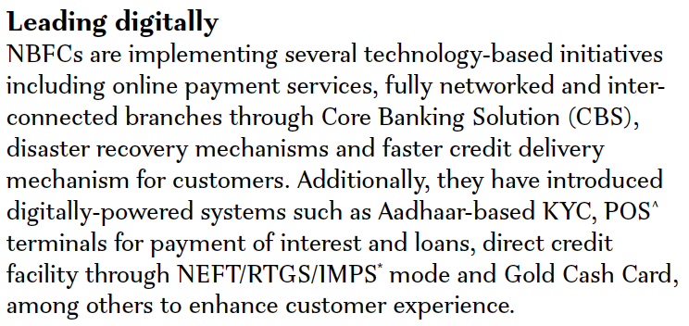

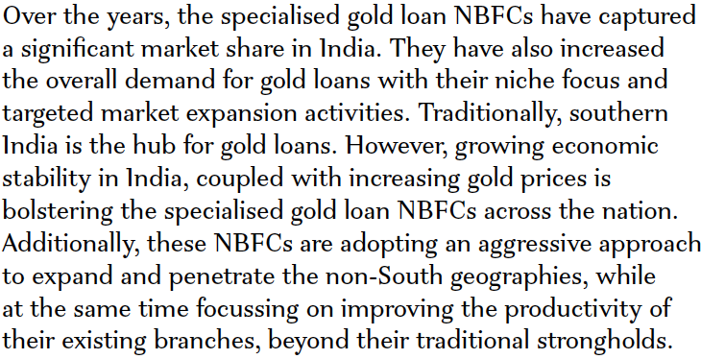

# Manappuram finance analysis

**First Mover Advantage:** Early technological and product innovations helped Manappuram Finance become one of the largest Gold Financing Companies in India (2nd after Muthoot Finance). Innovations include the introduction of the Core Banking System (CBS) to streamline loan disbursal procedures, short term gold loans of three and six month tenure to minimize risk, and rapid expansion in its non-gold portfolio, including Housing Finance, Microfinance, and Insurance.

**Gold Loan (LAG) Performance:** 13 different operational schemes are provided to customers with flexible interest rates. Gold loan AUM increased 55% and disbursements grew 18.5% from FY17 to FY18, reflecting the waning impact of GST and demonetization. Under **digital lending**, Online Gold Loan portfolio grew from 11.9% in FY17 to 32% in FY18 of the total gold loan book. Like Muthoot Finance, Manappuram Finance too has e-KYC services running for a year; however, Manappuram Finance has partnered with mobile wallets, including PAYTM and mPESA, which have helped reduce operating costs and have close to 2 lakh downloads. Future digital initiatives include a Manappuram-Yes Bank prepaid card and an e-locker system for enhanced security to threats.

**Small Medium Enterprise (SME) Performance:** The SME business is relatively small as it was launched in November 2017 in Maharashtra to cater to the undeserved segment.

**Diversification**: New Businesses helped support the overall AUM growth as microfinance (35.71% growth), home loans (20.71%), commercial vehicle loans (104.49%) and other non-gold loans (391.80%) portfolios registered strong growth. The nongold portfolio collectively grew by 59% during the year albeit on a low base. New businesses now (FY18) contribute nearly 25.5% of its consolidated AUM as against 19% last year, unlike those of Muthoot Finance that contribute to 10% of its consolidated AUM as of FY18 and plan to increase it to 20% by the year 2020.

**Impact of Sept 2018 Crisis:** Like Muthoot Finance, Manappuram Finance too has largely remained unaffected by the liquidity squeeze, thanks to shorter maturity of their assets. These gold loan NBFC’s have their average loans repaid in 3 to 4 months, which convinced the market of no asset-liability mismatch, measured by the duration gap. As a result, they were able to carry on business as usual and their limits were renewed on time.

**Supported Financial Ratios:** Although all profitability ratios fell by small margins due to reduced Net Revenue of ₹585.74 million from FY17 to FY18, Manappuram Finance continued to expand its customer base and branches. Because Manappuram Finance caters predominantly to the unorganized sector, which bore the brunt of demonetization and, as a result, had its working capital cycle severely disrupted, the return to normality for Manappuram Finance took longer than expected. Therefore, the first 2 quarters of the year saw little or no growth; it was only in the fourth quarter that growth actually picked up. To sum up, all ratios worsened, including the liquidity and efficiency ones, but not by huge margins that should cause concern for Manappuram Finance as growth has now picked up from the start of FY19 and they are targeting at growing the consolidated book by about 20% for FY1.

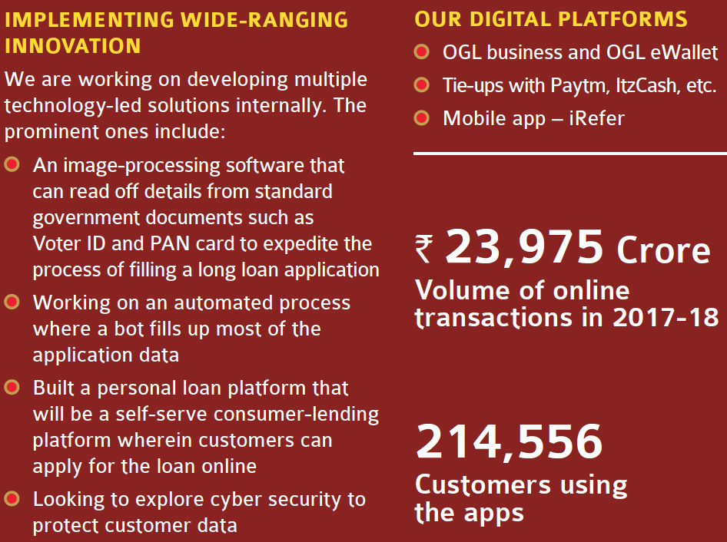

“

”

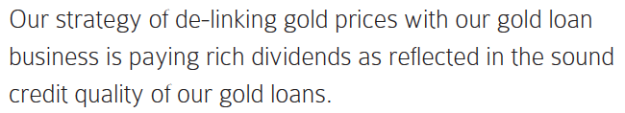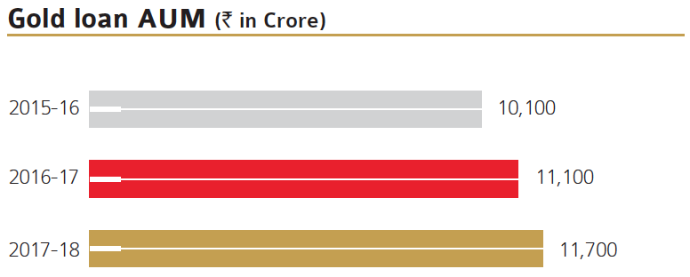 “

 ”

# Bajaj finance analysis

**USP**: Bajaj Finance is the leader of the NBFC industry in terms of **consumer finance**, which accounts for almost 50% of its consolidated AUM. Under consumer lending, Bajaj Finance offers consumer durables and digital products, including gold loans, 2 & 3 wheeler loans, home loans, personal loans, and their unique Existing Member Identification (EMI) card. Bajaj Finance has been the largest financier of Bajaj motorcycles and three-wheelers across FY17 – FY19 and provides amenities, such as their growing lifestyle finance and retail finance businesses, that a lot of other NBFC’s do not.

**Gold Loan (LAG) Performance**: Total gold loan portfolio increased by 56.9% from FY17 to FY19; however, gold loan portfolio as % of total assets reduced from 0.94% to 0.87% across the 3 years. This trend should not be viewed critically, as performance of LAG has been improving yearly, but the increase in LAG portfolio has been lower than the increase in total AUM (standalone or consolidated). Although Bajaj Finance doesn’t have an independent online gold loan system, customers can avail of their Gold Loan WOW process, which involves a door step service to the customer’s residence to process the loan.

**Digital Lending**: The EMI Network Card, provided under the Bajaj Finserv Mobikwik Wallet, caters mainly to the lifestyle finance and retail finance segment of the business. It allows customers to shop for various product categories online, such as home appliances, furniture, clothes, accessories, travel bookings, and medical treatments, and gain approval for loans. Moreover, its EMI Network Card has been gaining immense popularity from FY17 – FY19 with 18.5 million cards currently in operation versus 6.9 million cards in FY17.

**Small Medium Enterprise (SME) Performance:** Consolidated AUM increased by 19% from FY17-FY18 and by 38% from FY18-FY19. Bajaj Finance offers secured (mortgage loans) and unsecured (business and professional) loans to customers, mainly through their ‘Direct to Customer’ (D2C) Initiative. As a result of this initiative, professional loans AUM grew by 79% over FY18 and business loans AUM grew by 21% over FY18.

**Diversification**: Bajaj Finance is indubitably one of the most diversified NBFC’s in India and that is what sets them apart from other NBFC’s. By diversifying their business beyond housing finance, unlike other NBFCs, in sectors of rural lending, health and life insurance, and fixed deposits, Bajaj Finance has gained market capitalization of ₹ 2 trillion. Therefore, BFL has not only diversified risk across millions of customers and product categories, but also

diversified its risk and portfolio over 1800 urban and rural locations in India. BFL’s geographically distributed portfolio helps reduce concentration risks to the minimal.

**Impact of Sept 2018 Crisis:** Bajaj Finance saw its shares shoot up 35% over FY18-19, despite the crisis. Again, credit goes to their diversified business model, which helped them limit their exposure to housing finance loans, and kept their bad loan ratio at 1.5% versus 8.8% at Shriram Transport Finance Co. and 9.7% at Mahindra Rural Housing Finance Ltd. Also, its operating costs have been decreasing over recent years due to their asset-light model, which means that it owns relatively fewer capital assets compared to the value of its operations and leads to better efficiency of managing costs.

**Supported Financial Ratios:** Bajaj Finance’s Net Profit Margin % grew by 6% over FY17-FY18, along with an increase in ROA of 3.6% and ROE as well as Asset Turnover remaining stable at 0.2 and 0.18 respectively. These figures are mainly attributable to an increase in Net Income of 34.3% over FY17-FY18. Moreover, EPS grew from ₹ 34.01 to ₹ 44.16, as result of increased Net Income. A key ratio to notice is Debt to Equity, which fell from 5.64 to 4.16, indicating that more investor financing was used instead of creditor financing, leading to less risky business.

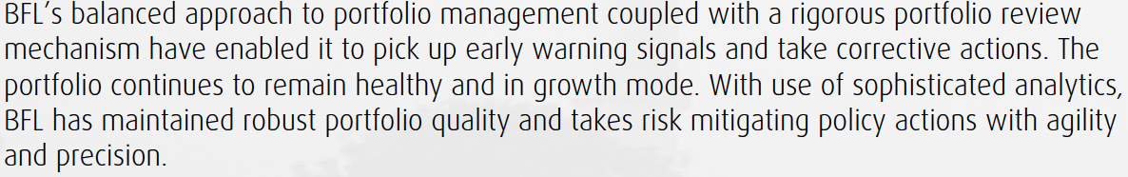“

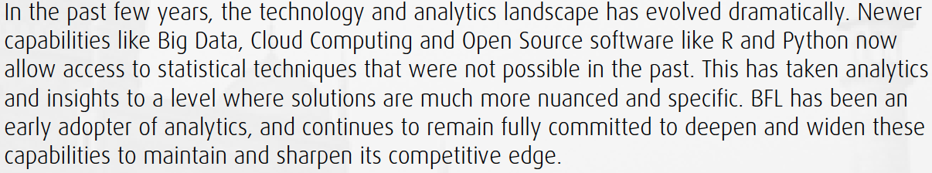

”

# Sources

1. https://www.livemint.com
2. https://economictimes.indiatimes.com
3. https://www.thehindu.com
4. https://www.thehindubusinessline.com
5. https://www.moneycontrol.com
6. https://www.business-standard.com
7. https://bankingfrontiers.com
8. https://www.bajajfinserv.in
9. https://www.manappuram.com
10. https://www.muthootfinance.com